**Sample 3**

|  |  |
| --- | --- |
| 1. | In covering a distance of 30 km, A takes 2 hours more than B. If A doubles his speed, then he would take 1 hour less than B. A's speed is: |

|  |  |  |  |
| --- | --- | --- | --- |
| [**A.**](javascript:%20void%200;) | 5 km/hr | [**B.**](javascript:%20void%200;) | 8 km/hr |
| [**C.**](javascript:%20void%200;) | 10 km/hr | [**D.**](javascript:%20void%200;) | 15 km/hr |

2. A man covers a distance on scooter. Had he moved 3kmph faster he would have taken 40 min less. If he had moved 2kmph slower, he would have taken 40min more. The distance is.

|  |  |  |  |
| --- | --- | --- | --- |
| [**A.**](javascript:%20void%200;) | 30 km | [**B.**](javascript:%20void%200;) | 40 km |
| [**C.**](javascript:%20void%200;) | 50 km | [**D.**](javascript:%20void%200;) | 55 km |

|  |
| --- |
| 3. A man takes 5hr 45min in walking to certain place and riding back. He would have gained 2hrs by riding both ways. The time he would take to walk both ways is? |
| |  |  |  |  | | --- | --- | --- | --- | | [**A.**](javascript:%20void%200;) | 7 hr 45 min | [**B.**](javascript:%20void%200;) | 7 hr 15 min | | [**C.**](javascript:%20void%200;) | 6 hr 45 min | [**D.**](javascript:%20void%200;) | 6 hr 15 min | |

|  |
| --- |
| 4. A is twice as good a workman as B and together they finish a piece of work in 18 days. In how many days will A alone finish the work? |
| |  |  |  |  | | --- | --- | --- | --- | | [A.](javascript:%20void%200;) | 31 days | [B.](javascript:%20void%200;) | 25 days | | [C.](javascript:%20void%200;) | 27 days | [D.](javascript:%20void%200;) | 29 days | |

5. If the number 517 * 324 is completely divisible by 3, then the smallest whole number in the place of * will be:

A. 1 B. 2 C. 4 D. 3

6. Look at this series: 7, 10, 8, 11, 9, 12, ... What number should come next?

|  |  |  |  |
| --- | --- | --- | --- |
| [**A.**](javascript:%20void%200;) | 7 | [**B.**](javascript:%20void%200;) | 13 |
| [**C.**](javascript:%20void%200;) | 10 | [**D.**](javascript:%20void%200;) | 12 |

7. Statement: Many people in ward X of the city are diagnosed to be suffering from a fatal malaria type.

Courses of Action:

I- The city municipal authority should take immediate steps to carry out extensive fumigation in ward X.

II - The people in the area should be advised to take steps to avoid mosquito bites.

|  |  |  |  |  |
| --- | --- | --- | --- | --- |
| [**A.**](javascript:%20void%200;) | Only I follow | [**B.**](javascript:%20void%200;) | Only II follows | |
| [**C.**](javascript:%20void%200;) | Neither I nor II follows | [**D.**](javascript:%20void%200;)Both I and II follow | |  | |

**8.** Odometer is to mileage as compass is to

|  |  |  |  |
| --- | --- | --- | --- |
| [**A.**](javascript:%20void%200;) | Speed | [**B.**](javascript:%20void%200;) | Needle |
| [**C.**](javascript:%20void%200;) | Hiking | [**D.**](javascript:%20void%200;) | Direction |

|  |  |  |  |  |  |  |  |  |
| --- | --- | --- | --- | --- | --- | --- | --- | --- |
| **9.** The primeminister dismisses criticism that he has ---- the economy and social issues.   |  |  |  |  | | --- | --- | --- | --- | | [**A.**](javascript:%20void%200;) | advanced. | [**B.**](javascript:%20void%200;) | recovered. | | [**C.**](javascript:%20void%200;) | proceeded. | [**D.**](javascript:%20void%200;) | neglected. | |

10. Look at this series: F2, __, D8, C16, B32, ... What number should fill the blank?http://books.tamilcube.com/image/blank.gif

|  |  |  |  |
| --- | --- | --- | --- |
| [**A.**](javascript:%20void%200;) | A16 | [**B.**](javascript:%20void%200;) | E4 |
| [**C.**](javascript:%20void%200;) | G4 | [**D.**](javascript:%20void%200;) | E3 |

11. Which figure completes the series? http://books.tamilcube.com/image/blank.gif

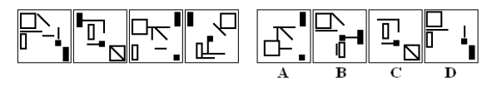

12. Which figure completes the statement? http://books.tamilcube.com/image/blank.gif

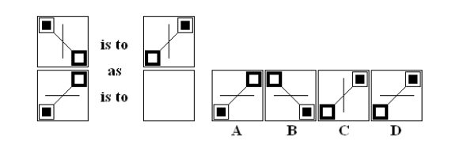

13. Which figure completes the grid?

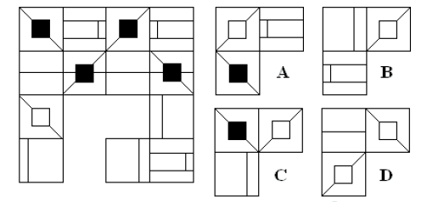

14. Which figure complete the series?http://books.tamilcube.com/image/blank.gif

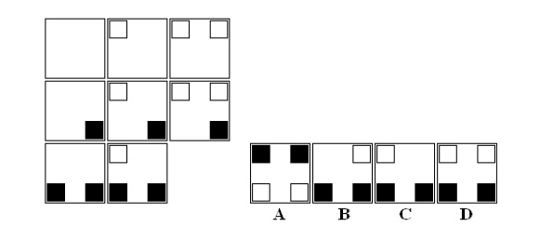

**Read the paragraph and answer accordingly.**

The government of an island nation is in the process of deciding how to spend its limited income. It has $7 million left in its budget and eight programs to choose among. There is no provision in the constitution to have a surplus, and each program has requested the minimum amount they need; in other words, no program may be partially funded. The programs and their funding requests are:

* Hurricane preparedness: $2.5 million  
* Harbor improvements: $1 million  
* School music program: $0.5 million  
* Senate office building remodeling: $1.5 million  
* Agricultural subsidy program: $2 million  
* National radio: $0.5 million  
* Small business loan program: $3 million  
* International airport: $4 million

**15. Senators from urban areas are very concerned about assuring that there will be funding for a new international airport. Senators from rural areas refuse to fund anything until money for agricultural subsidies is appropriated. If the legislature funds these two programs, on which of the following could they spend the rest of the money?**

A. the school music program and national radio

B. hurricane preparedness

C. harbor improvements and the school music program

D. small business loan program

E. national radio and senate office building remodeling

**16. If the legislature decides to fund the agricultural subsidy program, national radio, and the small business loan program, what two other programs could they fund?**

A. harbor improvements and international airport

B. harbor improvements and school music program

C. hurricane preparedness and school music program

D. hurricane preparedness and international airport

E. harbor improvements and hurricane preparedness

**17. If the legislature decides to fund the agricultural subsidy program, national radio, and the small business loan program, the only other single program that can be funded is**

A. hurricane preparedness.

B. harbor improvements.

C. school music program.

D. senate office building remodeling.

E. international airport.

“You may have heard that tomatoes and processed tomato products like tomato sauce and canned tomatoes protect against some types of cancer. The cancer-preventing properties of tomato products have been attributed to lycopene. It is a bright red pigment found in tomatoes and other red fruits and is the cause of their red color. Unlike other fruits and vegetables, where nutritional content such as vitamin C is diminished upon cooking, processing of tomatoes increases the concentration of lycopene. Lycopene in tomato paste is four times more than in fresh tomatoes. This is because lycopene is insoluble in water and is tightly bound to vegetable fiber. Thus, processed tomato products such as pasteurized tomato juice, so up, sauce, and ketchup contain the highest concentrations of lycopene. Cooking and crushing tomatoes as in the canning process and serving in oil-rich dishes such as spaghetti sauce or pizza greatly increase assimilation from the digestive tract into the bloodstream. Lycopene is a fat-soluble substance, so the oil is said to help absorption to a great extent.”

**18. According to the passage, it is true that lycopene ----.**

A) can only be found in processed tomato products

B) loses its cancer-preventing property when the tomato is processed

C) lowers the risk of having cancer only when it is consumed together with vitamin

D) is absorbed by the body more easily when accompanied by the oil

E) is a pigment which is solved quickly in water

**19. It can be understood from the passage that as far as the lycopene intake is concerned ----.**

A) lycopene hardly offers any protection against diseases such as cancer

B) one can get the highest amount of lycopene through eating fresh tomatoes

C) there is a correlation between the lycopene consumption and the prevention of some cancer types

D) there have been no reported side effects or toxicity associated with intake

E) tomato products contain high concentrations of lycopene and fat

**20. It can be understood from the passage that ----.**

A) lycopene is what gives some fruits their color

B) no credible evidence has been found to support an association between lycopene intake and a reduced risk of cancer

C) processed tomato products include the lowest concentrations of lycopene

D) there are several health problems that may result from consuming a great deal of lycopene

E) unlike the popular belief, fat doesn't help the absorption of lycopene in the body